## **Objectives**

* Explain about React forms
* Define controlled components
* Explain about various input controls
* Explain about handling forms
* Explain about submitting forms

In this hands-on lab, you will learn how to:

* Implement React forms
* Use various input controls like textbox, button and textarea

## **Prerequisites**

The following is required to complete this hands-on lab:

* Node.js
* NPM
* Visual Studio Code

## **Notes**

Estimated time to complete this lab: **60 minutes.**

Create a React App named “ticketraisingapp” which will help to raise a complaint and get it resolved.

Create a component named “ComplaintRegister” with a form containing a textbox to enter the employee name and a textarea to enter the complaint. Use “handleSubmit” event of the button to submit the complaint and generate a Reference number for further follow ups in the alert box.

**Output Expected:**

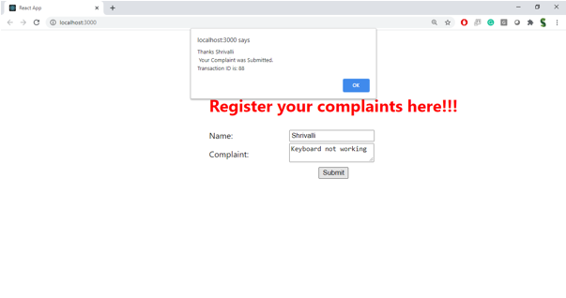

**Hint:**

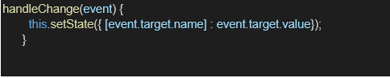

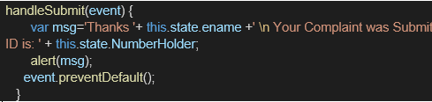

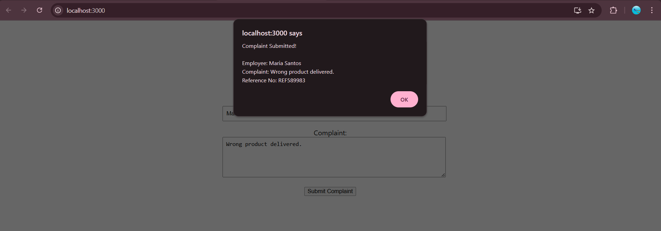

ComplaintRegister.js

import React, { useState } from 'react';

function ComplaintRegister() {

const [employeeName, setEmployeeName] = useState('');

const [complaint, setComplaint] = useState('');

const handleSubmit = (e) => {

e.preventDefault();

if (!employeeName || !complaint) {

alert('Please fill in both fields.');

return;

}

// Generate random reference number

const refNo = 'REF' + Math.floor(100000 + Math.random() * 900000);

alert(

`Complaint Submitted!\n\nEmployee: ${employeeName}\nComplaint: ${complaint}\nReference No: ${refNo}`

);

// Reset form fields

setEmployeeName('');

setComplaint('');

};

return (

<div style={{ padding: '20px', maxWidth: '500px', margin: 'auto' }}>

<h2>Raise a Complaint</h2>

<form onSubmit={handleSubmit}>

<div style={{ marginBottom: '15px' }}>

<label>Employee Name:</label><br />

<input

type="text"

value={employeeName}

onChange={(e) => setEmployeeName(e.target.value)}

placeholder="Enter your name"

style={{ width: '100%', padding: '8px' }}

/>

</div>

<div style={{ marginBottom: '15px' }}>

<label>Complaint:</label><br />

<textarea

value={complaint}

onChange={(e) => setComplaint(e.target.value)}

placeholder="Describe your complaint"

rows="5"

style={{ width: '100%', padding: '8px' }}

></textarea>

</div>

<button type="submit">Submit Complaint</button>

</form>

</div>

);

}

export default ComplaintRegister;